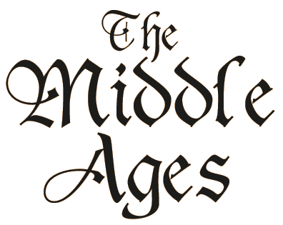
Year 7 Middle Ages Project
To help us to understand a little more about life in the Middle Ages, you will each research an aspect of that period that we have not covered in class, and teach it to the class. You must use the textbook to help you in your research, but I expect further research to be carried out via the internet or other books from our History library. It is due on Tuesday 9th January (email your presentation: Claire@olivetreeschool.cat)
- Your lesson will be no more than 25 minutes in total (please practise this so you do not exceed the time limit)
- You will give a presentation on your research that does not exceed 10 minutes (this can be a PowerPoint or Prezi, and must include images and if possible a short video – 1 minute maximum)
- You will think of an activity for you and the rest of the class to complete based on your presentation. This could be a diary entry, a letter, a role play, a speech, a card sort, etc. Please ask me if you have any doubts. The activity should not exceed 10 minutes to complete. Any work not finished in class will be assigned as homework.
- The final part of your lesson will be feedback from the rest of the class on the activity, followed by a short quiz (to be included at the end of your presentation). Maximum time 5 minutes

- Your presentation will be marked out of 9, according to the following criteria:
  - Timing
  - Content (research, video)
  - Layout (images, text, organisation)
  - Activity
  - Presentation skills (voice projection, enthusiasm for subject, subject knowledge, engagement with audience, clear explanations)

- The following themes will be presented during the two weeks after Christmas. Name:

  - 9/01 Castles 1 (chapters 3.1A – 3.2B, pp. 42 – 49) __Kai______
  - 9/01 Castles 2 (chapters 3.3A – 3.4, pp. 50 – 55) __Sergi____
  - 11/01 Life in a Medieval village (chapters 5.1A & B, pp. 72 – 75) __León_____
  - 11/01 Life in a Medieval town (chapters 5.2A & B, pp.76 – 79) __Juan José_
  - 12/01 How Smelly were the Middle Ages? (chapter 5.3, pp. 80 – 81) __Ulises____
  - 12/01 Entertainment (chapters 5.4 & 5.6, pp. 82 – 83, 86 - 87) __Sebas____
  - 16/01 Football in the Middle Ages (chapter 5.5, pp. 84 – 85) __Maarten__
  - 16/01 Food & Fashion (chapters 5.7 & 5.9, pp. 88-89, 92-93) __Erik_____
  - 18/01 The story of the English Language (chapter 5.8, pp. 90-91) __Angelina__
  - 18/01 Knights and Heraldry (chapters 5.10, 5.11, 5.12 pp. 94 – 99) __Luca_____
  - 19/01 Women in the Middle Ages (chapters 5.13 – 5.14, pp. 100 – 103) __Ariadna___
  - 19/01 Law and Order (chapters 8.1 & 8.2, pp. 138 - 131) __Aureli____
Have fun!

