Act 4 Scene 3

Lines 1-56
Macduff tells Malcolm how Scotland suffers at the hands of Macbeth. Malcolm is at first unsure as to whether Macduff has been sent by Macbeth. He refers to Macbeth as a “tyrant” and ironically says to Macduff that Macbeth “hath not touched you yet”, however the audience know that this is not the case and anticipate the arrival of the news. Malcolm suspects that Macduff will sacrifice him to Macbeth, to which Macduff responds by saying “I am not treacherous”; the bluntness of this statement reflects the offence he takes at such an accusation. Malcolm worries that Macduff may betray him on the king’s orders and he alludes to the fall of Lucifer from grace when he says “Angels are bright still, though the brightest fell”. His suggestion that “all things foul would wear the brows of grace” echoes the themes of seeming and duplicity, where “false face must hide what the false heart doth know”. Macduff feels disheartened by Malcolm. Malcolm says he doubts him because he doesn’t understand why he left his wife and child behind and that he fears for his own safety.
Macduff is upset that Malcolm suspects him of trying to deceive him and tries to leave. Malcolm tests his loyalty by pretending that he himself is full of faults. He worries that even after killing Macbeth and “tread[ing] on the tyrant’s head” that he will be just as poor a king and will make “black Macbeth…seem pure as snow”. Macduff doubts that this is possible and uses the language of hell to describe Macbeth as “a devil...damned in evils”.

Lines 57-100

What words does Malcolm use to describe Macbeth in line 57-60?

What does he say are his faults? And how does Malcolm respond to each of them?
Malcolm’s fault | Macduff’s reaction

Lines 100-139

Fill in the thought bubble for Macduff below:
O Scotland! Scotland! ... O nation miserable!
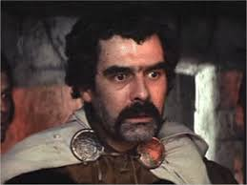

What do Macduff’s words reveal about his true loyalties?

Malcolm, reassured by Macduff’s passionate outburst, retracts his admissions and says it was a test. He goes on to reveal his true qualities. What does he say they are?

Malcolm asks Macduff why he is silent. What is he thinking? Is he relieved or confused? Does he trust Malcolm?

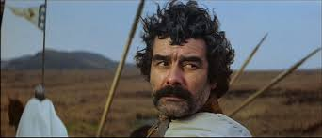

Lines 139-158
A doctor enters and they discuss the power of Edward the Confessor, the English King, to cure a disease known as ‘the king’s evil’. He was the first of the kings to try cures by touching “wretched souls”. He is referred to as “this good King” who cures the sick, has the gift of prophecy and is famous for his virtues.
In what ways might these qualities be contrasted with Macbeth’s? And Malcolm’s?

Lines 158-225
Ross arrives with the latest news from Scotland. He describes the country’s suffering under Macbeth’s rule, but lies to Macduff and tells him that his family are well.
Why does Ross initially lie about what has happened?

Ross reports that many good men are preparing to rebel against Macbeth. Malcolm confirms his plan to invade Scotland, with the support of the English army. Ross then reveals the truth of what has happened to Macduff’s family, telling him “your wife and babes/ Savagely slaughtered.” His language is emotive, perhaps out of genuine shock at the brutality of the crime, but perhaps also in attempt to motivate Macduff and enlist him in the fight against Macbeth.
Consider Macduff’s reaction to the news of his family’s death in comparison with Macbeth’s reaction to the news that Lady Macbeth has died. Summarise their main ideas below:

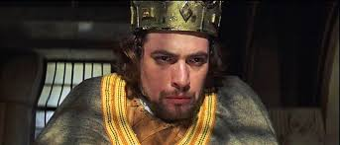
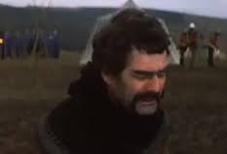

Macduff is not ashamed to cry and says that part of being a man is to “feel it as a man”. One of Lady Macbeth’s tactics in persuading Macbeth to kill Duncan, and later to gain self-control at the banquet is to question his masculinity.
What image of masculinity does Macduff present in this scene? How would the audience, then and now, feel at watching his grief played out on the stage?

Lines 229-240
Malcolm encourages Macduff to “let grief / Convert to anger” and to use his pain to fuel his revenge. Macduff resolves to act and want to fight “this fiend of Scotland” face to face. The audience anticipate Macbeth’s inevitable downfall at the hands of Macduff and empathise with his motivation to kill Macbeth.
Macduff resolves to kill Macbeth at the end of this scene. Technically this is regicide, how does Shakespeare justify such an act in this situation?

Malcolm’s final words reflect his resolve to take action. He is prepared and has thought through his plan carefully, which contrasts with Macbeth earlier in the play. He refers to the “powers above” in helping him to oust Macbeth and his reference to “night… that never finds day” extends the metaphor established earlier in the play, where night time embodies the evil and darkness experienced by the people of Scotland at the hands of Macbeth and “day” is the hope for goodness to prevail.
What impression have you received of Malcolm in this scene? What kind of king is he likely to be?

